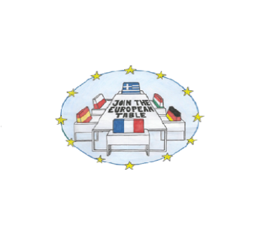

“JOIN THE EUROPEAN TABLE “ACTIVITIES IN TARRAGONA
SUNDAY  10TH | 19.00 | ARRIVAL IN TARRAGONA AND HOSTS WELCOME.
MONDAY  11TH | 9.30  10.00 | WELCOME SPEECH BY THE SCHOOL HEADMISTRESS AND THE DEPUTY MAJOR  L’ATENEU PERFORMANCE (EU RIGHTS AND VALUES )
 | 11.00-12.00 | NGO PROACTIVA OPEN ARMS ( doctor Jesús Galvez)
 | 12.00-12.30 | Coffee BREAK
 | 12.30-14.00 | NGO STOP MARE MORTUM
 | 14.00-15.00 | SCHOOL TOUR
 | 15.00-16.30 | Lunch break
 | 16.30-18.00 | TEACHERS WORKSHOP
TUESDAY 12TH | 10.00-12.00 | TARRAGONA GUIDED TOUR
 | 12.00- 13.00 | TOWNHALL VISIT
 | 17.00-19.00 | NGO URV SOLIDARIA PRESENTATION (UNIVERSITY)
 | 21.00 | OFFICIAL DINNER (TEACHERS AND HEADMASTERS) EL TERRAT RESTAURANT
WEDNESDAY 13TH | 8.00-18.00 | EXCURSION to MONTBLANC (MEDIEVAL VILLAGE) POBLET MONASTERY AND ESPLUGA CAVES.
THURSDAY 14TH | 8.30-9.30 | SCHOOL LESSONS ATTENDANCE
 | 9.30-11.30 | PARTNERS PRESENTATIONS (REFUGEES FILMS, BOOKS, DOCUMENTARIES...NGOS)
 | 11.30-12.00 | COFFEE BREAK
 | 12.00-  13.30 | NGO CEA(R) PRESENTATION
 | 13.30-15.00 | PARTNERS PRESENTATIONS (REFUGEES FILMS, BOOKS, DOCUMENTARIES...NGOS)
 | 16.30 | TEACHERS WORKSHOP
 | 21.00 | TEACHERS DINNER

FRIDAY 15TH | 8.30 | MEETING AT SCHOOL
 | 9.30-12.00 | RED CROSS VISIT AND WORKSHOP
 | 12.00-12.30 | Coffee break
 | 12.30-14.00 | EU VALUES AND FUNDAMENTAL RIGHTS POSTERS
 | 14.00-15.00 | CERTIFICATES handout / PHOTOCALL
 | 15.00-20.00 | FREE TIME
 | 20.00-00.30 | DINNER AND FAREWELL PARTY
SATURDAY 16TH | 8.00-16.00 | TRIP TO BARCELONA AIRPORT AND BACK HOME!

*IF THERE WERE ANY CIRCUMSTANCES BEYOND OUR CONTROL THIS PROGRAMME COULD VARY SLIGHTLY.

